# Tribute Page

### A MINI PROJECT REPORT

#### Submitted by

#### Group/Team No: G15/T19

**Tarun Kumar,2310991229**

**Tejas Gupta,2310991230**

**Tushar, 2310991231**

***Submitted to***

**Ms. Gaganpreet Kaur**

#### in partial fulfillment for the award of the degree of

## BACHELEOR OF ENGINEERING

***in***

COMPUTER SCIENCE & ENGINEERING



**CHITKARA UNIVERSITY**

**CHANDIGARH-PATIALA NATIONAL HIGHWAY**

**RAJPURA (PATIALA) PUNJAB-140401 (INDIA)**

##### October,2023

**ABSTRACT:**

The tribute page is a dedicated online space that honors and commemorates a person,

group, or concept. Through a blend of text, images, and possibly multimedia elements, it

seeks to convey the significance and impact of the subject being celebrated. This form of

digital homage serves as a means to share stories, highlight achievements, and pay

respects, fostering a sense of remembrance and appreciation.

**TABLE OF CONTENTS**

|  |  |  |
| --- | --- | --- |
| Sr.No | Section | Page No. |
| 1. | Introduction | 4 |
| 2. | Problem Statement | 5 |
| 3. | Technical Details | 6 |
| 4. | Key Features | 7 |
| 5. | Project Highlights | 8 |
| 6. | Conclusion | 12 |
| 7. | References | 13 |

**INTRODUCTION**

The purpose of this project is to create a Memorable Tribute page for multiple individuals allows us to celebrate the diverse achievements and contributions of those who have left a lasting impact. This page serves as a collective homage, weaving together narratives that showcase the unique stories, talents, and legacies of each person honored. Through shared memories and reflections, it becomes a digital tapestry, preserving the essence of these remarkable individuals for others to appreciate and draw inspiration from.

**PROBLEM STATEMENT**

The webpage revolves around paying tribute to Multiple individual and effectively conveying there life story, achievements, and inspirational impact to visitors. To Create a web page that provides an overview of there life, including there early life, achievements, contributions, and inspirational journey.

Include sections that highlight key aspects of there life, such as his early life, achievements, contribution,inspiration, philanthropic activities, legacy and conclusion.Incorporate engaging and informative content that narrates there life story and emphasizes impact on the society

**TECHNICAL DETAILS**

1)HTML (Hypertext Markup Language): HTML is used for structuring the content of the web page.

2)CSS (Cascading Style Sheets): CSS is used for styling the web page, including fonts, colors, layout, and positioning.

3)Text Editor or Integrated Development Environment (IDE): You can use a text editor like Visual Studio Code or an IDE like WebStorm for writing and editing HTML and CSS code.

4) The JavaScript code defines a function showHiddenPass for toggling the visibility of a password input.

5)It takes two parameters: the ID of the password input and the ID of the eye icon.

6)The function uses event listeners to switch between password and text visibility and update the eye icon accordingly.

7) Combining HTML and CSS, developers create visually appealing and structured web pages. HTML establishes the content hierarchy, while CSS enhances the presentation, resulting in a cohesive and user-friendly web experience.

8) CSS utilizes selectors to target HTML elements and apply styles. Selectors can be based on element names, classes, IDs, or other attributes. Styles are defined with properties and values, influencing aspects like text formatting, background colors, and margins.

1. **KEY FEATURES**

**The Key Features of Our Project**

1)HTML Structure: You might want to wrap your content in HTML tags such as <html>, <head>, and <body> to ensure proper structuring.

2)CSS Styling: Your CSS for the header is good, but the styling for the heading and paragraph text should be consistent and organized. Consider using a separate CSS file or inline styles for cleaner code.

3)Background Color: The attribute bgcolor in the <body> tag is an outdated HTML attribute. It's better to use CSS for setting the background color.

4)Image Alignment: The image of Milkha Singh is set to float left. If you want the text to wrap around it, you should use proper CSS styles for alignment and spacing.

5)Constructs a login form with input fields for email and password, along with corresponding icons and labels.

6)Implements a JavaScript function for toggling password visibility with an eye icon, enhancing user experience.

7)Applies external styles from "login.css" to create a visually appealing and consistent design.

**PROJECT HIGHLIGHTS**

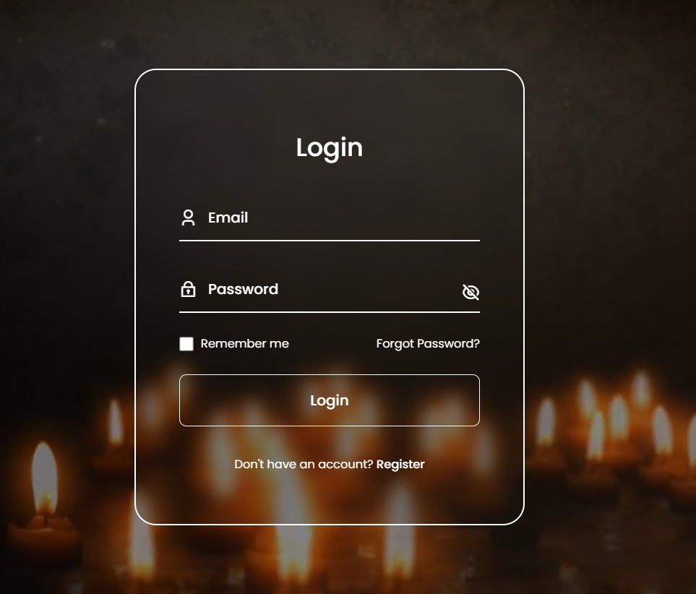

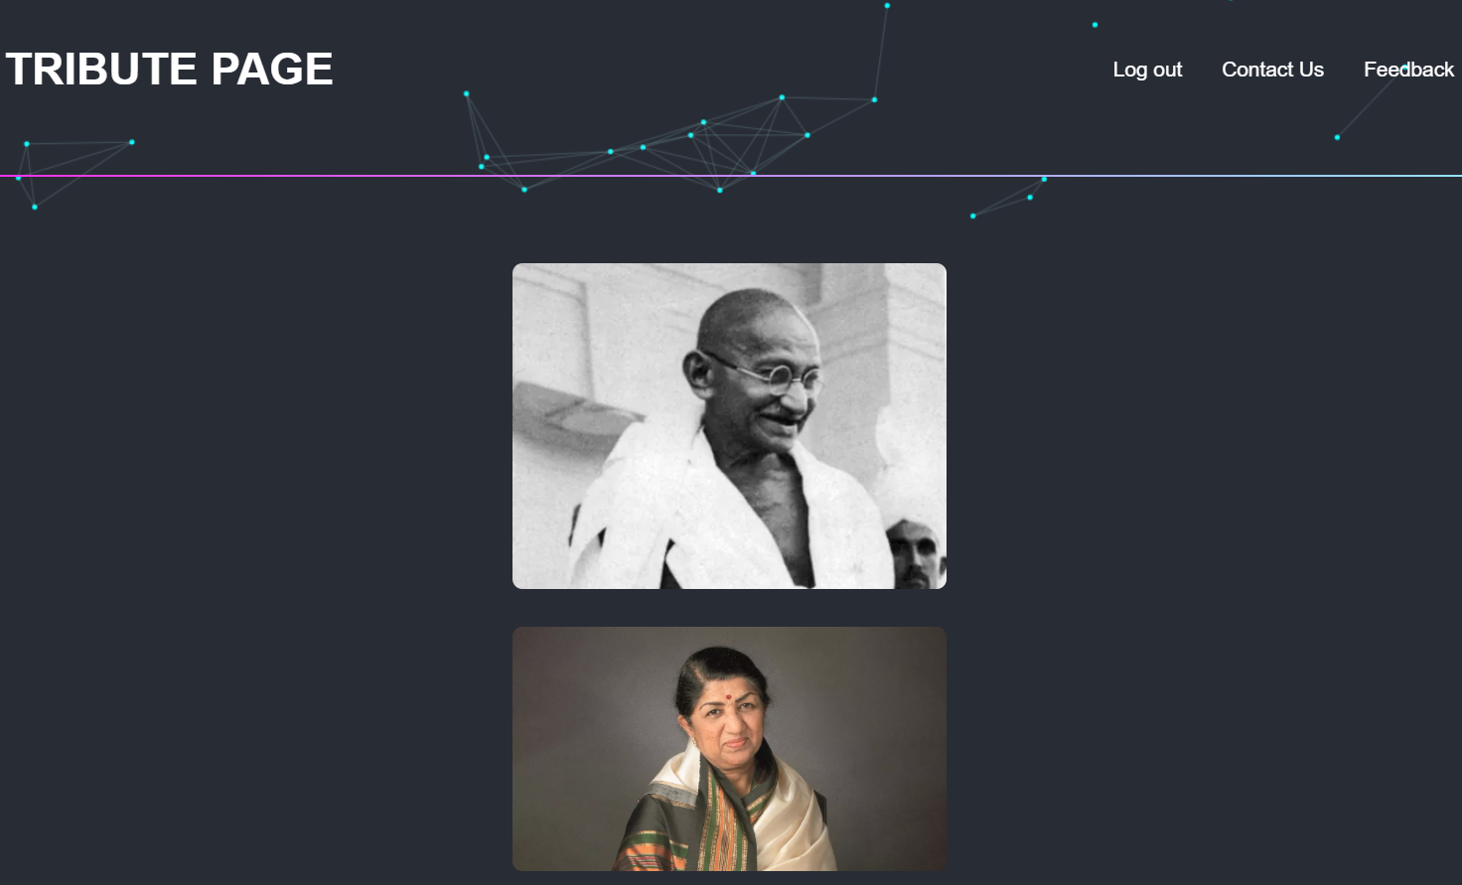

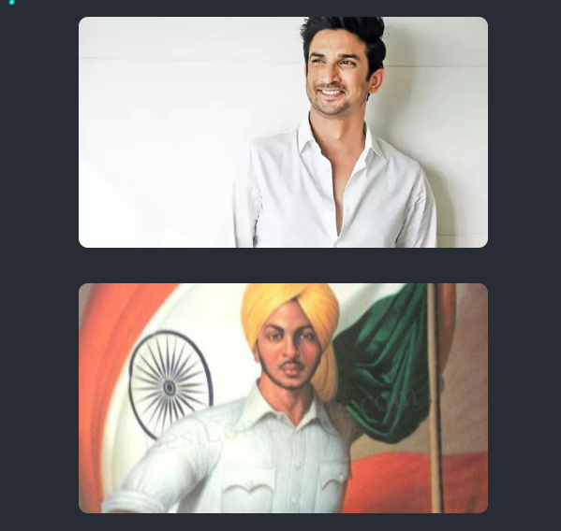

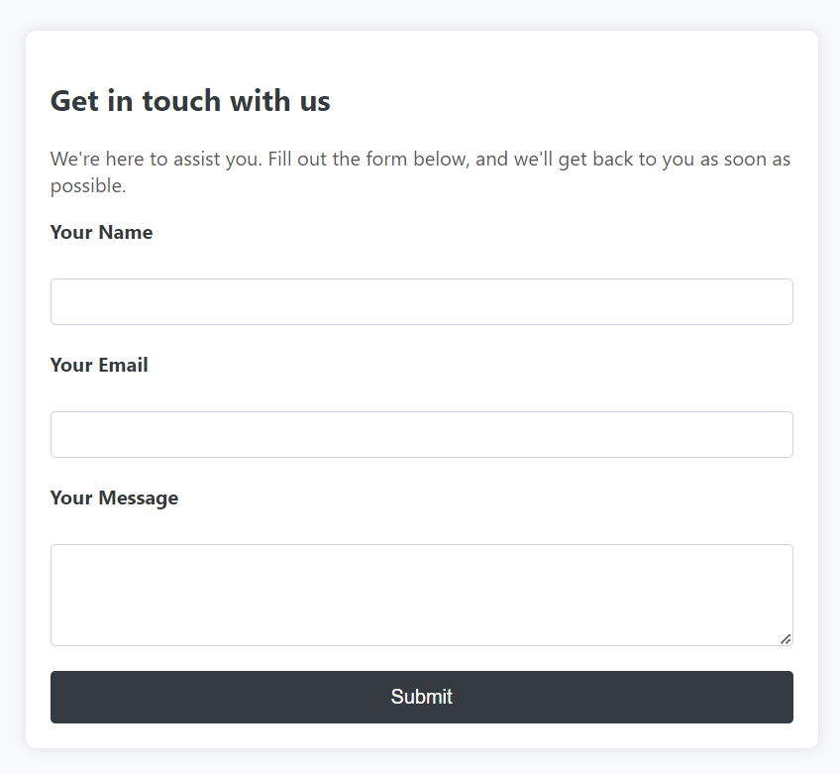

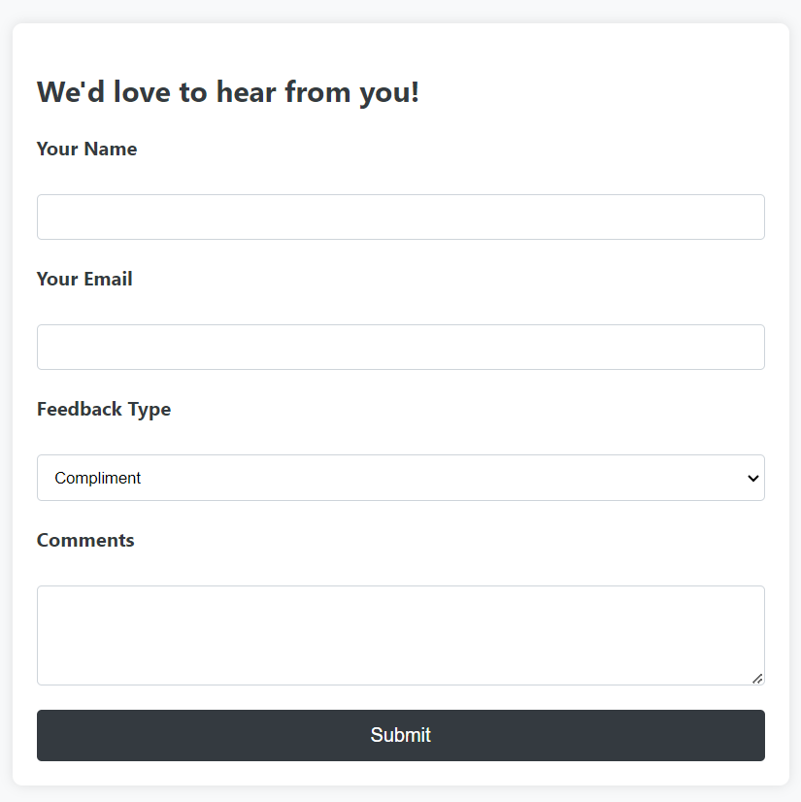

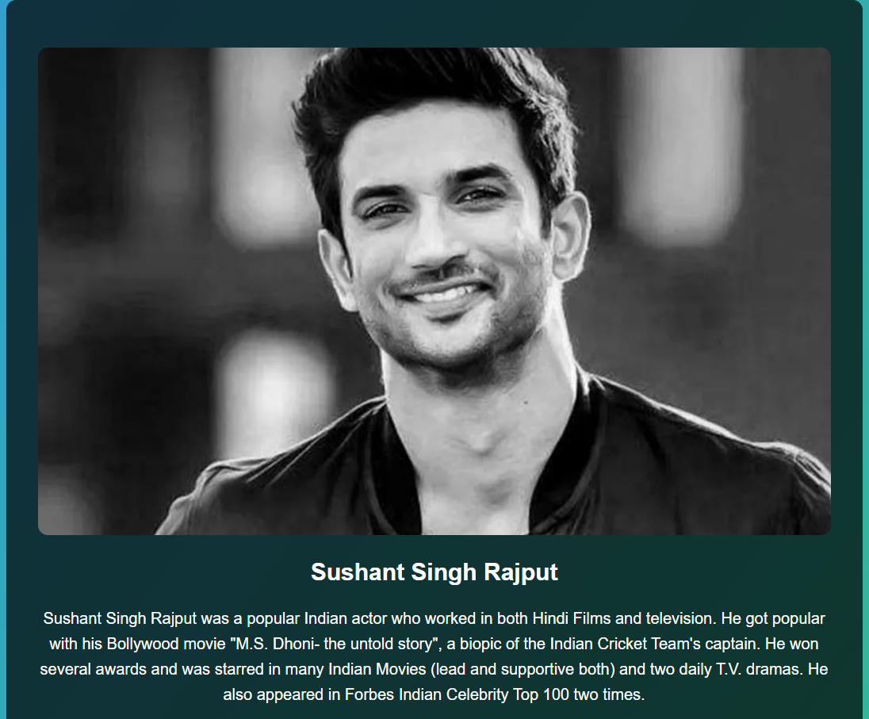

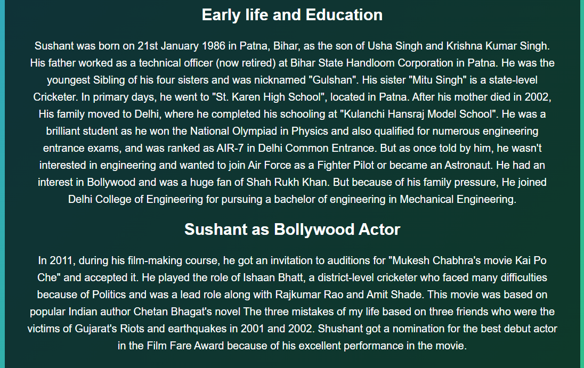

**CONCLUSION**

In remembering of Indian legend a symbols of determination, and an inspiration to us all. there remarkable journey will continue to inspire generations. Thank you for visiting and paying tribute to this remarkable souls. For more information or to share your own thoughts and memories, please feel free to contact us tejasgupta079@gmail.com

With deepest respects,Feel free to adapt and expand upon this conclusion to best fit the purpose and tone of your tribute web page.

**REFERENCES**

* <https://en.wikipedia.org/wiki/Milkha_Singh>
* <https://en.wikipedia.org/wiki/Lata_Mangeshkar>
* <https://en.wikipedia.org/wiki/Bhagat_Singh>
* <https://en.wikipedia.org/wiki/Sushant_Singh_Rajput>
* <https://en.wikipedia.org/wiki/Mahatma_Gandhi>
* <https://en.wikipedia.org/wiki/A._P._J._Abdul_Kalam>
* https://en.wikipedia.org/wiki/Kalpana_Chawla